In LAB TASK 4
TASK#1
Code
#include <stdio.h>
#include <conio.h>
int main()
{
int number1, number2, sum;
printf("Enter first number");
scanf("%d",&number1);
printf("Enter second number");
scanf("%d",&number2);
sum=number1+number2;
printf("The sum is: %d",sum);
}
Name: Abdul Rafay Nawaz Roll no: 26K-3142
Code screenshot
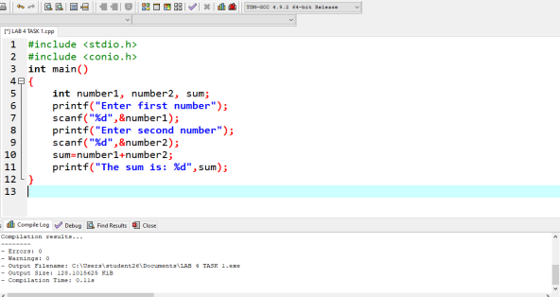Name: Abdul Rafay Nawaz Roll no: 26K-3142
Code output
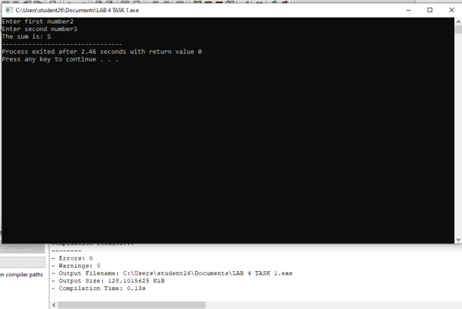Name: Abdul Rafay Nawaz Roll no: 26K-3142
TASK#2
Code
#include <stdio.h>
#include <conio.h>
int main()
{
float number1, number2, percentage;
printf("Enter Obtained marks");
scanf("%f",&number1);
printf("Enter total marks");
scanf("%f",&number2);
percentage=number1/number2;
printf("The percentage is: %f %%",percentage*100); }
Name: Abdul Rafay Nawaz Roll no: 26K-3142
Code screenshot
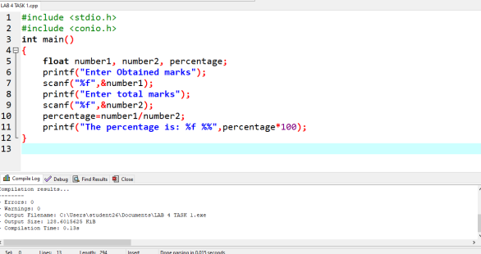Name: Abdul Rafay Nawaz Roll no: 26K-3142
Code Output
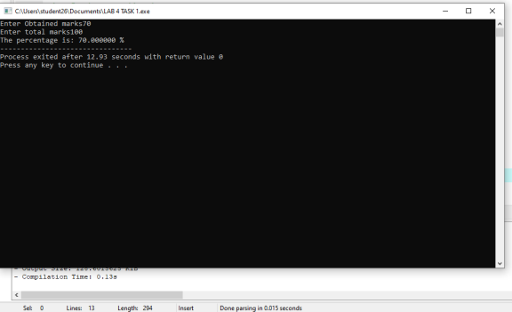Name: Abdul Rafay Nawaz Roll no: 26K-3142
TASK #3
Code
#include <stdio.h>
#include <conio.h>
int main()
{
int num;
printf("Enter the number");
scanf("%d", &num);
if(num%2==0)
printf("The number is even");
else
printf("The number is odd");
}
Name: Abdul Rafay Nawaz Roll no: 26K-3142
Code screenshot
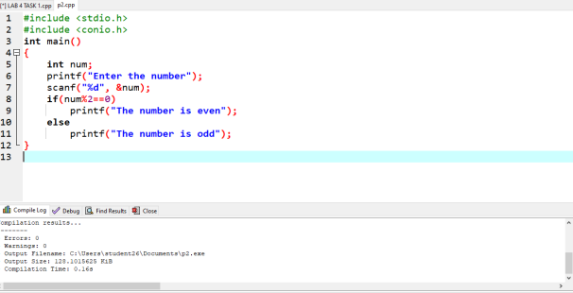Name: Abdul Rafay Nawaz Roll no: 26K-3142
Code output
Name: Abdul Rafay Nawaz Roll no: 26K-3142
Task #4
Code
#include <stdio.h>
#include <conio.h>
int main()
{
int num;
printf("Enter the person age");
scanf("%d", &num);
if(num>=18)
printf("The person is eligible to vote");
else
printf("The person is not eligible to vote"); }
Name: Abdul Rafay Nawaz Roll no: 26K-3142
Code screenshot
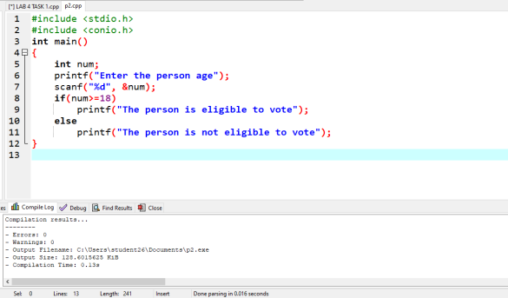Name: Abdul Rafay Nawaz Roll no: 26K-3142
Code output
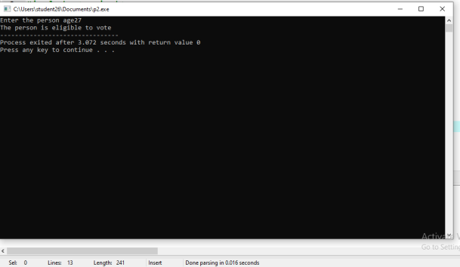Name: Abdul Rafay Nawaz Roll no: 26K-3142

